

**Installation GUIDE**Version 4.0

Isabelle LECOMTE

October 2018

Hi-sAFe is a model included in Capsis platform, there is no stand-alone version available.

This documentation is related to Capsis installation from an installer, either downloaded from the Hi-sAFe download page or provided by a Hi-sAFe modeller.

Hi-sAFe may be installed with the same installer on machines under Windows, Linux or Mac OS X.

In case of trouble during the installation, have a look at the Capsis FAQ :

<http://capsis.cirad.fr/capsis/documentation/faq>

# Ensure java 1.8 is installed on your computer

Capsis is developed for Java 1.8, if you have a more recent version, some problems can occur. To check the correct version of Java is installed and available, open a Terminal and check the answer to this command **java –version** (must answer java 1.8.x)

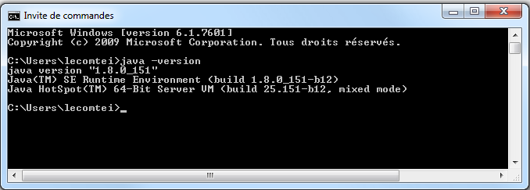

If java is not found on your system or the version is not 1.8.x, please download and install the correct version of java for your operating system, if you have a 64bit PC install a 64bit java version!

For Windows and Linux: install JRE from  
<http://www.oracle.com/technetwork/java/javase/downloads/jre8-downloads-2133155.html>

For MacOS: install JDK from   
[http://www.oracle.com/technetwork/java/javase/downloads/jdk8-downloads-2133151.html](http://www.oracle.com/technetwork/java/javase/downloads/jdk8-downloads-2133151.html%20%20%20%20%20%20%20%20%20%20%20%20)

# Run the CAPSIS installer

**On Windows and Mac, run the installer** (capsis-setup.jar) by double clicking on it and follow the install instructions.

On Linux, open a terminal, go in to the directory where “capsis-setup.jar” is located by typing :

**cd */directory/where/capsis-set.jar/is/located***

Then, to activate the installer, type :

**Java –jar capsis-setup.jar**

and follow the install instructions.



On step 4: Choose a target path

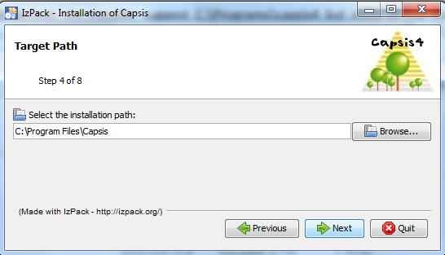

By default on a Windows operating system, the installer suggests C:\Program Files\Capsis but most of the time you will not have write privileges for this. Best advice is to create a new folder named **C:\project\capsis4** or **D:\project\capsis4.**

On Mac and Linux, such advice can be followed. Default installation paths are respectively /Applications/Capsis and /home/*username*/Capsis, but other directories can be chosen. Just make sure you have the right permissions on it.

The minimum required size is 160 Mo.

On step 7, desktop shortcuts will be created. Most of the time this step does not work and you will have to stop the installation here by closing the window. Installation is DONE!

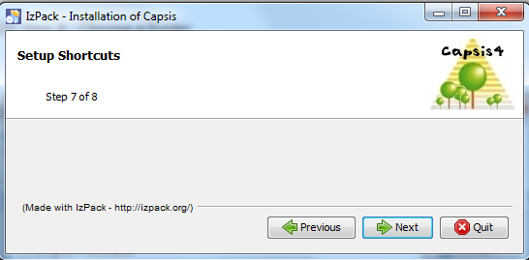

# Increase capsis running memory

Run the capsis command SETMEN with the RAM you want to assign to the capsis execution (1024 – 2048 – 4096 etc…)

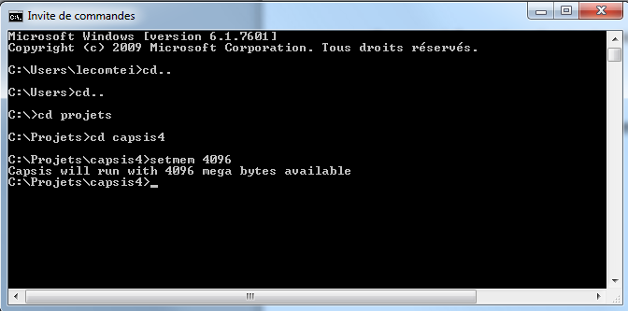

# Start Capsis and Hi-sAFe

When the install is complete, use the **Start menu** or the **Desktop shortcut** to start Capsis.

If you cannot find a shortcut, create one with **C:\Projets\capsis4\capsis.bat**

You can also open a terminal and execute the following commands:

#under windows

cd project\capsis4

capsis

#under Linux / Mac OS X

cd /Applications/Capsis *(or : cd /path/where/Capsis/is/located)*

sh capsis.sh (graphic interface)

sh capsis.sh –p script safe.pgms.ScriptGen */simulation/directory/simfile.sim* (batch mode)

Remark : on Linux, the only batch mode is available to run simulations.

A window console and Capsis GUI will open simultaneously.

|  |  |
| --- | --- |
|  |  |

Choose create a new project and click on **OK**

Give a name to the project, choose **Hi-sAFe** model and click on **Initialize**

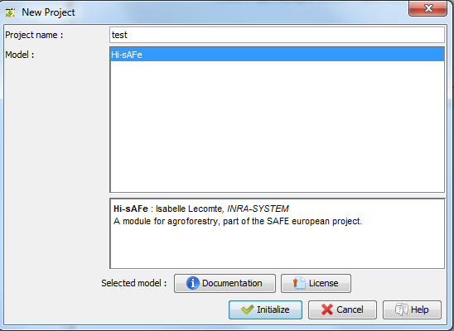

Initialise the project by giving a plot description file name. Click on **Browse button** to choose a file on your computer, and **OK**

One **default.pld** file is available in the capsis directory   
**C:\project\capsis4\data\safe\plotDescription**

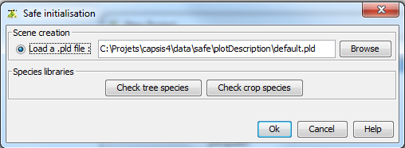

Click on the root step (**0/0/0a**) and then on **Hisafe viewer** (on the left part of the screen)

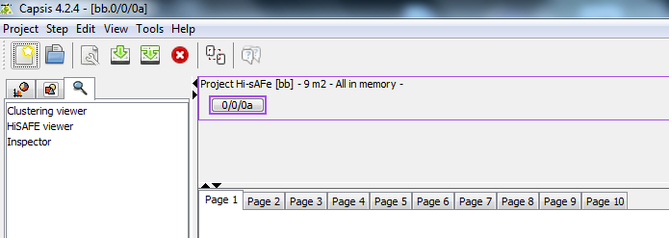

You can check the plot description with the Hi-sAFe viewer.

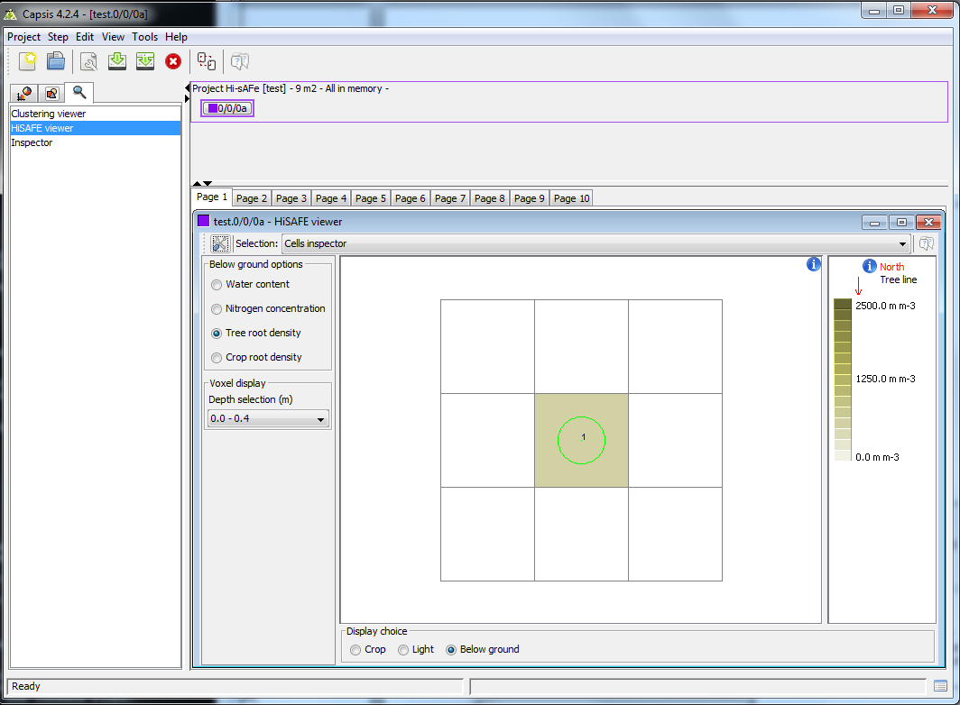

To run a Hi-sAFe simulation: right click on the root step of the project to choose “**Evolution**”. If right click doesn’t work you can use the menu **Step > Evolution**

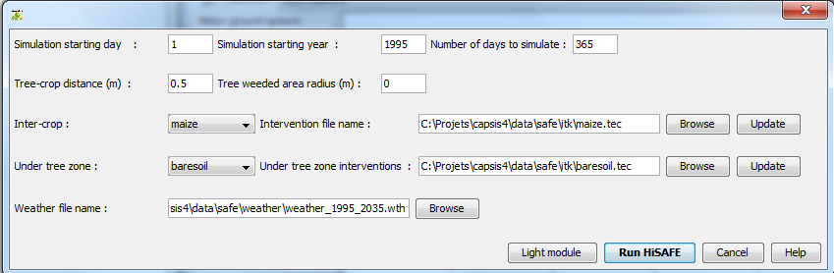

Fill all simulation information:

* Simulation starting date (in DOY)
* Simulation starting year
* Number of days for the simulation (1-365 max)
* Inter-crop species name (baresoil – maize – wheat – durum-wheat – soybean – rape – grass)
* Under tree zone species name (baresoil – maize – wheat – durum-wheat – soybean – rape – grass)
* Inter-crop interventions file name
* Under tree zone crop interventions file name
* Weather file name

Some default files are available in:

* **C:\project\capsis4\data\safe\itk** for crop interventions
* **C:\project\capsis4\data\safe\weather** for weather file

Then click on “**Run Hi-sAFe**”



The progress bar at the bottom of the screen shows the evolution of the simulation.

When the simulation is done the last step appears next the root step.

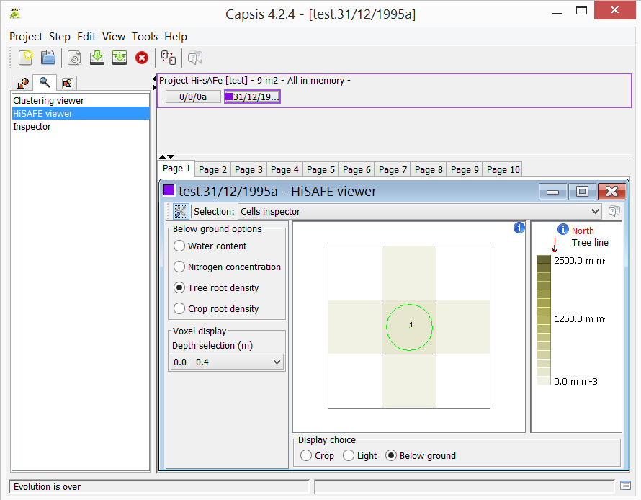

**For more information about using Hi-sAFe, read the complete Hi-sAFe user guide.**

# More documentation

For more documentation and information about Hi-sAFe, please visit the website:

<https://www1.montpellier.inra.fr/wp-inra/hi-safe/en/>